**Name:** Davy Nolan

**Performed:** Friday October 27th,

2017, 16:00-18:00 pm

**Date:** 29th October 2017

**Class:** Electrotechnology CS1025

***Laboratory Experiment 1***

**Introduction**

In the first part of the experiment demonstrates a simple circuit diagram to be constructed. It is critical to understand how to read schematic circuit diagrams and do understand the different symbols. The following circuit consisted of a 5V d.c. supply, a 220 Ω resistor and an LED (light emitting diode). The circuit is connected in series.



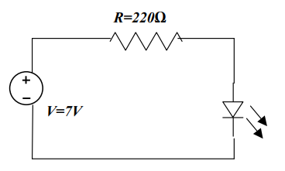 **Resistor 1**

**5 V Power Supply**



**LED**

In the second part of the experiment, another resistor was added to the circuit in parallel. Measurements were taken for each configuration of resistor (R2=200Ω, 100Ω, 50Ω respectively).

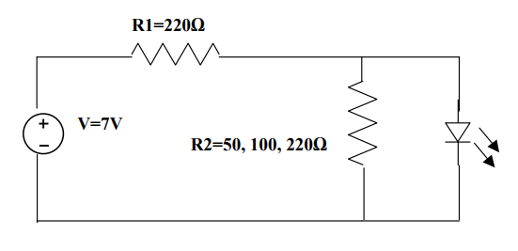 **Resistor 2**

The following results were recorded for part 1 and part 2:

1. The voltage drop across the LED.
2. The voltage drop across the resistor(s).
3. The current through the resistor(s) and LED.

**Measurements/Results**

Part 1:

|  |  |
| --- | --- |
| Voltage drop across LED | 2.69 V |
| Voltage drop across Resistor | 2.32 V |
| Current through LED | 6.24 mA |
| Current through Resistor | 6.24 mA |
| Does the LED light up? | Yes |

Part 2:

(Resistors in parallel)

|  |  |  |  |
| --- | --- | --- | --- |
|  | 50Ω resistor | 100Ω resistor | 220Ω  resistor |
| Voltage drop across LED | 0.95 V | 3.44 V | 2.69 V |
| Voltage drop across Resistor 1 | 4.05 V | 1.56 V | 2.32 V |
| Voltage drop across Resistor 2 | 0.95 V | 3.44 V | 2.69 V |
| Current through LED | 6.25mA | 6.3mA | 6.24mA |
| Current through Resistor 1 | 6.25mA | 6.3mA | 6.24mA |
| Current through Resistor 2 | 6.25mA | 6.3mA | 6.24mA |

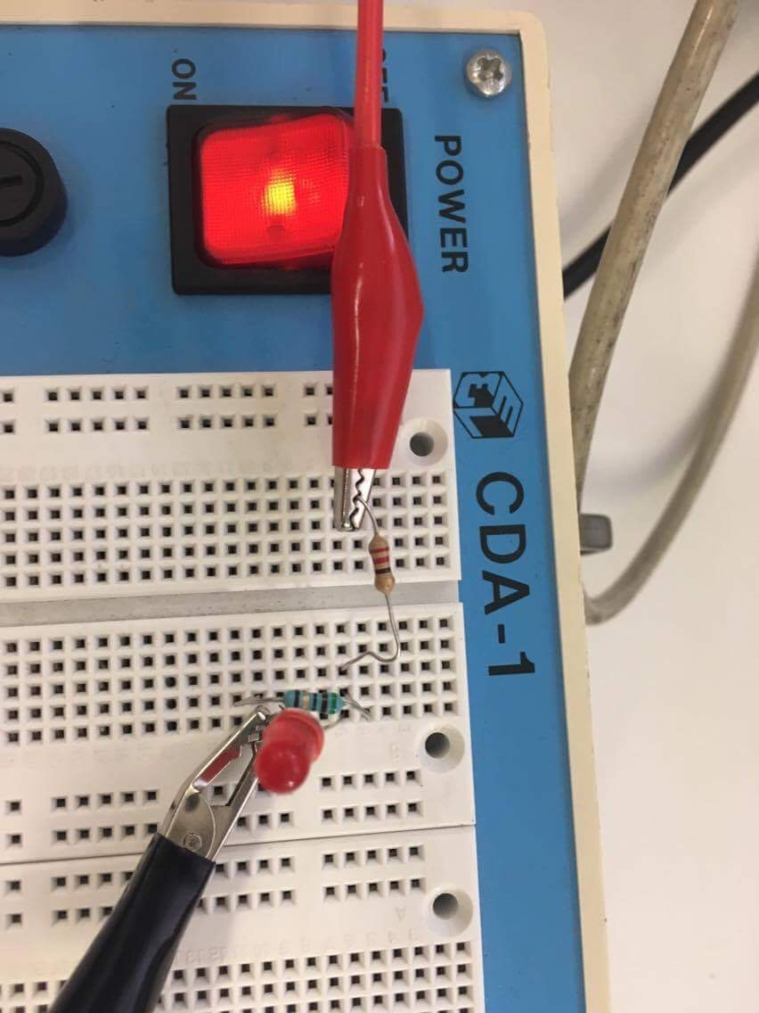The following photograph shows the connected circuit in parallel of part 2.

**Observations**

Kirchhoff’s Voltage Law

Gustav Kirchhoff’s Voltage Law is the second of his fundamental laws we can use fir circuit analysis. His voltage law states that for a closed loop series path, the algebraic sum of all the voltages around any closed loop in a circuit is equal to zero. This is because a circuit loop is a closed conducting path so no energy is lost. (reference: www.electronics-tutorials.ws/dccircuits/kirchoffs-voltage-law.html)

In other words, the sum of ALL the potential differences around the loop must be equal to zero. This idea is commonly known as the conservation of energy, as moving around a closed loop, or circuit, you will end up back to where you started in the circuit and back to the same initial potential with no loss of voltage around the loop. ANY VOLTAGE DROPS MUST BE EQUAL TO ANY VOLTAGE SOURCES MET ALONG THE WAY.

From the measurements in part 2 of the experiment, Kirchhoff’s Law of voltage has been verified. The voltage drop across the LED was 0.95 V and the voltage drop across the Resistor 1 was 4.05 V.

Workings:

5 V – 0.95 V – 4.05 V = **0**

However, in part 1 of the experiment, the voltage drop across the LED was 2.69 V and the voltage drop across the resistor 1 was 2.32.

Workings:

5 V – 2.69 V – 2.32 V = **-0.01** (This result is off 0 by -0.01. This may have been due to minor human error in reading the results or connecting the circuit).

Kirchhoff’s current law

**Gustav Kirchhoff’s Current Law** is one of the fundamental laws used for circuit analysis. His current law states that for a parallel path the total current entering a circuits junction is exactly equal to the total current leaving the same junction. This is because it has no other place to go as no charge is lost. (reference: http://www.electronics-tutorials.ws/dccircuits/kirchhoffs-current-law.html)

In other words, the algebraic sum of ALL the currents entering and leaving a junction must be equal to zero.

From the measurements in part 1 and part 2 of the experiment, the current remains the same entering the circuit and leaving the circuit, therefore, Kirchhoff’s Current Law has been verified.

**Conclusion**

Our expectation of the notion of Kirchhoff’s laws of Current and Voltage seems correct. The data collected supports this notion very well as the voltage drops add up to 0 Volts and the Current remains the same entering and leaving the circuit. However there was a point where the results were off by 0.01 volts, this will be written off as human error in interpreting results or carrying out the experiment.